

Politecnico di Milano  
A.A. 2015-2016  
Software Engineering 2 Project

My Taxi Service

Project Plan

Giovanni Brena (858328), Andrea Canale (858638)

Contents

1 Introduction ……………………………..

1.1 Purpose ……………………………

2 Project size ……………………………….

2.1 Function Points Analysis…………..

2.2 Unadjusted Function Points (UFP)..

2.3 Value Adjustment Factor (VAF)…..

2.4 Adjusted Function Points (FP)…….

3 Project effort and price…………………..

3.1 COCOMO …………………………

3.2 Assumptions ………………………

3.3 Scale Drivers ………………………

3.4 Cost Drivers ……………………….

3.5 Results ……………………………..

4 Tasks and Schedules ……………………

5 Resources ………………………………..

6 Risk estimation …………………………..

6.1 Risks analysis …………………….

1. Introduction
   1. Purpose  
      The following document purpose is to provide a detailed Project Plan for MyTaxiService project. First will be provided estimates for project size, effort and cost using Function Points and CoCoMo methods then tasks, schedules, resources allocation and risk analysis.
2. Project size

This section reports a size estimation of the project made by Function Points technique. The development effort is based on the system functionalities.

* 1. Function Points Analysis  
       
     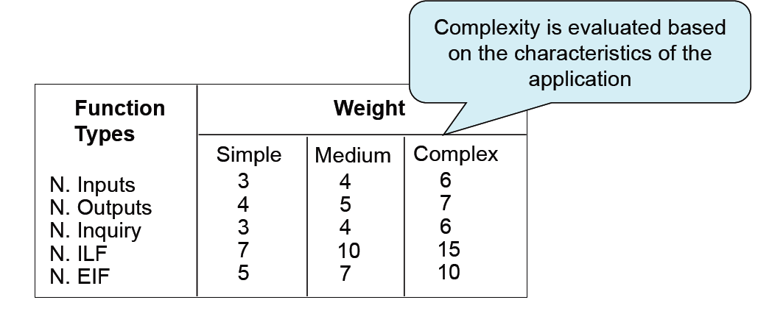

(notation S, M, C identify “Simple”, “Medium” and “Complex”)

Internal Logic Files (ILF):  
This type of functions concern set of data used and managed by the application.

* + - Registered User (M)
    - Taxi Driver (M)
    - Zone (S)
    - Queue (M)
    - Run (C)
    - Reservation (S)
    - Taxi Exception (S)

**Total: 66 FPs**

External Logic Files (ELF):  
This type of functions concern set of data used by the application but generated and maintained by other applications.

* + - Geocoding Places (M)
    - Geocoding Drivers (C)

**Total: 12 FPs**

External Inputs:  
This type of functions concern operations to elaborate data coming from the external environment.

* + - Login (S)
    - Logout (S)
    - Update User Info (S)
    - Make Call (C)
    - Make Reservation (C)
    - Delete Reservation (S)
    - Set availability (M)
    - Accept Call (C)
    - Refuse Call (S)
    - Update registered drivers list (S)

**Total: 40 FPs**

External Outputs:  
This type of functions concern operations to generate data for the external environment.

* + - Get Taxi Position (C)

**Total: 7 FPs**

External Inquiries:  
This type of functions concern operations that involve input and output but very few elaboration on data.

* + - Get User Info (S)
    - Get Ride History (S)
    - Get drivers list (S)

**Total: 9 FPs**

* 1. Unadjusted Function Points (UFP)  
       
     UFP = ILF + ELF + ExInputs + ExOutputs + ExInquiries   
     = 66 + 12 + 40 + 7 + 9 = **134 FP**
  2. Value Adjustment Factor (VAF)  
       
     VAF is used to adjust UFP taking into consideration 14 parameters called General System Characteristics (GSC). Each of these parameters get a value between 1 and 5.

Data Communication: 3

Distributed data processing: 4

Performance: 2

Heavily used configuration: 2

Transaction rate: 4

Online data entry: 4

End user efficiency: 4

Online update: 5

Complex processing: 1

Reusability: 3

Installation ease: 1

Operational ease: 3

Multiple sites: 3

Facilitate change: 3

**VAF = sum(GSC) * (0.01) + 0.65 = 1.09**

* 1. Adjusted Function Points (FP)  
       
     Adjusted FP (effort estimate) = UFP * VAF   
     = 140 * 1.09 = **153 FP**

1. Project effort and price  
   1. COCOMO (COnstructive COst MOdel)  
        
      This section provides an efford and cost estimate using COCOMO II model.
   2. Assumptions  
        
      Due to uncertainty about implementation source code lenght we provide 3 different results for 3 possible values of SLOC (Source Lines of Code): 2000, 4000, 12000.  
      We also assumed a salary of 2000$ / month for each developer involved into project.
   3. Scale Drivers  
        
      Scale drivers consist in 5 high level parameters having a value between this set: Very Low, Low, Nominal, High, Very High, Extra High.
      * Precedenteness: **Low**
      * Development Flexibility: **Low**
      * Architecture / Risk Analysis: **Nominal**
      * Team Cohesion: **Very High**
      * Process Maturity: **Nominal**

* 1. Cost Drivers

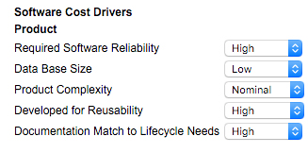

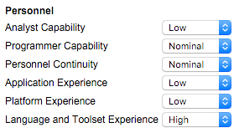

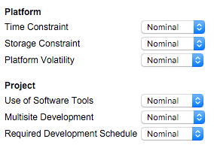

* 1. Results  
       
     Here we present results given by the model computation under the assumptions made on the project.

CASE A: 2000 SLOC  
**Effort**: 9.6 Person-months  
**Schedule**: 7.7 months  
**Required staff**: 2 people  
**Cost**: 19 246 $

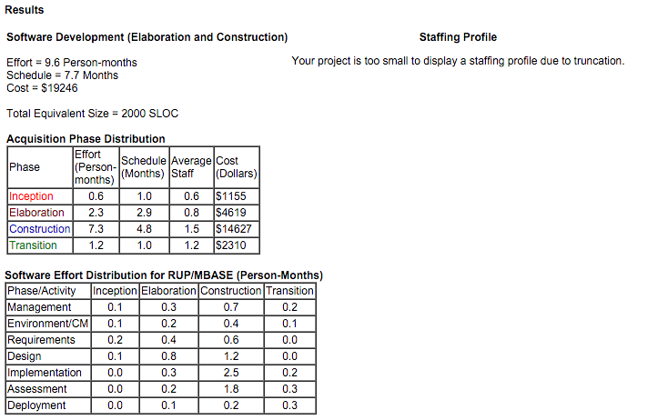

CASE B: 4000 SLOC  
**Effort**: 20.6 Person-months  
**Schedule**: 10 months  
**Required staff**: 3 people

**Cost**: 41 264 $

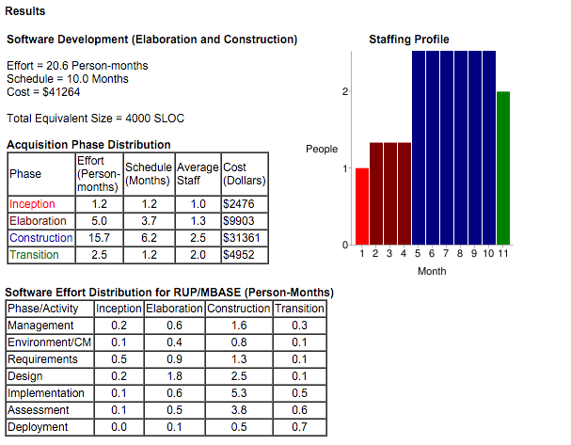

CASE C: 12000 SLOC  
**Effort**: 69.1 Person-months  
**Schedule**: 14.8 months  
**Required staff**: 5 people

**Cost**: 138 213 $

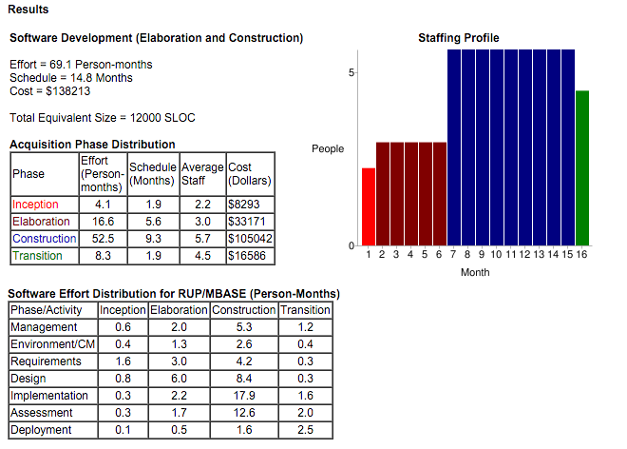

1. Tasks and Schedules

The task of our project are:

* [T1] Deliver of RASD(Requirement Analysis and Specification Document )
* [T2]Deliver of DD (Design Document)
* [T3]Deliver of ITPD (Integration Test Plan Document)
* [T4]Deliver of Project Plan Document
* [T5]Prepare of a brief presentation (20 min ) about the previous document to show to our customer
* [T6]Implementation of the software and preparation of unit tests
* [T7]Perform the integration tests (specified in ITPD) on the system

The schedule of the project is based on the COCOMO estimation performed in the 3.5 paragraph CASE A of this document which fix the duration to 8 months.

The deadlines are fixed for the first five tasks accordingly to the project rule.

One important modification of the project rules is the duration of the DD preparation raised to 7 weeks due to the fact that the code inspection is not performed. We choose to give more time to DD preparation due to the criticality of this task which is the first responsible of delays and cost raise.

|  |  |  |  |  |
| --- | --- | --- | --- | --- |
| TASK | Start | End | Duration | Dependencies |
| T1 | 15-10-2015 | 06-11-2015 | 3 weeks |  |
| T2 | 06-11-2015 | 7-01-2015 | 7 weeks | T1 |
| T3 | 7-01-2016 | 21-01-2016 | 3 weeks | T2 |
| T4 | 21-01-2016 | 02-02-2016 | 2 weeks | T3 |
| T5 | 02-02-2016 | 09-02-2016 | 1 week | T4 |
| T6 | 09-02-2016 | 22-05-2016 | 10 weeks | T5 |
| T7 | 22-05-2016 | 06-06-2016 | 2 weeks | T6 |

Here the schedule of the project followed by the Gantt diagram:

1. Resources

In this chapter its shown how the resources are allocated to the project.

Each task are divided in macroareas in an high level way of

abstraction ,for the first four task they represent the chapter of the related document.

Regarding the implementation the task is divided in the tiers which compose the project: Database Tier , Mobile Tier , Web Tier ,Business Tier.

The resources are allocated in a way to optimize the time and quality of the software:

-In the first Month each member implement the tier in which they are more skilled (Web Tier for Canale,Mobile Tier for Brena)

-In the second one each member focus on test and implementing of new tiers (Canale DB Tier, Brena Business Tier)

-In the third one as soon as the DB tier is finished , Canale join Brena in the implementation of Business Tier

-In the fourth one each member performs tests on the completed Tiers

The divisions of works between members are listed and shown in the following tables:

5.1RASD

|  |  |  |  |
| --- | --- | --- | --- |
| Member | Week 1 | Week 2 | Week 3 |
| Canale | Introduction | Spec.req | AlloyModeling&  Revision |
| Brena | Introduction | Overall Descr. &Spec.Req. | Revision |

5.2Design Document

|  |  |  |  |  |
| --- | --- | --- | --- | --- |
| Member | Weeks 1-2 | Week 3-4 | Week 5-6 | Week 8 |
| Canale | HighLevelComp | DB Design | Algorithm Des. | Revision |
| Brena | HighLevelComp | UX Interface | Interface&  Algorithm Des. | Revision |

5.2ITPD Document

|  |  |  |
| --- | --- | --- |
| Member | Weeks 1 | Week 2 |
| Canale | Integration Strategy | Individual Steps |
| Brena | Introduction &  Integration Strategy | Revision |

5.3 Project Planning

|  |  |  |
| --- | --- | --- |
| Member | Weeks 1 | Week 2 |
| Canale | Task | Schedule & Revision |
| Brena | Introduction &  FP &Cocomo | Schedule & Revision |

5.4 Presentation

The presentation task doesn’t need a graphical representation of work because the members work together on the preparation of the slides.

5.5 Implementation

|  |  |  |  |  |
| --- | --- | --- | --- | --- |
| Member | Month 1 | Month 2 | Month 3 | Month 4 |
| Canale | WebTier | Test WT &  DB Tier | Business Tier | Test DB Tier+  Test Business Tier |
| Brena | MobileTier | Test MT &  BusinessTier | BusinessTier | Test BusinessTier |

5.6 Integration Tests

|  |  |  |  |  |
| --- | --- | --- | --- | --- |
| Member | Week 1 | Week 2 | Week 3 | Week 4 |
| Canale | CoreSB | BT components +DBT | BT+DBT+CoreSB  +MobileClient | BT+DBT+  WebClient+  MobileClient |
| Brena | BT components | BT components  +CoreSB | BT+DBT+CoreSB  +WebClient | BT+DBT+  WebClient+  MobileClient |

1. Risk estimation
   1. Risk Analysis  
        
      **Known Risks:**Basing our analysis on MyTaxiService RASD and Design Document developing team can be quite safe about **Product Size Risks** if human resources has been choosen accordingly to the size and effort analysis (chapter 2 and 3).  
      Also **Experience Risks** have to be taken into account while composing the project team.   
        
      Risks connected to **Business Impact** have been restricted by a deep analysis of requirements made by project team and stakeholders. This does not ensure absence of business risks, in particular we think that the due to poor innovativeness of the system (many Taxi Booking platforms are already in the market) could constitute a risk in collecting customers. At same time, less newness reduces **Technological Risks** and provides developing examples and guidelines to build a robust product.